ABSTRACT

Data visualization is the discipline of trying to understand data by placing it in a visual context so that patterns, trends and correlations that might not otherwise be detected can be exposed. Matplotlib is the most popular python plotting library. It is a low-level library with a Matlab like interface which offers lots of freedom at the cost of having to write more code. Pandas DataFrame is a two-dimensional, size-mutable, potentially heterogeneous tabular data structure with labelled axes (rows and columns). A DataFrame is a two-dimensional data structure, i.e., data is aligned in a tabular fashion in rows and columns.
In this project, we combine all the above mentioned DataFrame, Data visualization in Python to analyse the data which is stored in csv format. The data is then later imported using read_csv() function for visualization of the data in the form of different charts. We took the literacy rate of India related data to work with our project.
ACKNOWLEDGMENT

We thank Lord Almighty for the blessings he had bestowed on us which resulted in finalization of our project.
We would like to express our sincere gratitude to this institution, St. Kuriakose Public School, Mariamala, Kaduthuruthy & our Manager Rev. Fr. BINO CHERIYIL for the worthy support extended to us. We also thank and express sincere gratitude to our honourable Principal Ms. RENJI WILSON CHOCKATTU, for providing us with best facilities and atmosphere for our project development and its realization. We are grateful to the Head of the Department, Ms. NILNA BABU, for her constant encouragement and support.
We are highly obliged to our project coordinators and guides Mr. GODWIN JOSEPH and Ms. NILNA BABU , for the valuable guidance and help during the course of this project work. We also like to express our gratitude to the lab staffs who helped us to make the project a success.
This acknowledgement will stand incomplete if our parents, friends, seniors & classmates are not thanked for enduring their prayers and support to us, which was inevitable for the realization of this work. Last but not the least we are thankful to each other in this project group for being co-operative, patient and hardworking for the successful completion of this project.

GROUP MEMBERS

ANALEENA JOVI
ANGEL ANNA VINOJ
ANGEL TESSA BIJU

TABLE OF CONTENTS

CHAPTER.NO | TITLE | PAGE.NO
 | ABSTRACT | 1
 | ACKNOWLEDGMENT | 2
 | GROUP MEMBERS | 3
 | TABLE OF CONTENTS | 4
1. | INTRODUCTION  1.1 General Introduction  1.2 Introduction to Python  1.3 Introduction to Pandas  1.4 Introduction to Pandas DataFrame  1.5 Introduction to data Visualization  1.6 Introduction to csv files | 6  6  6  6  7  7  7
2. | OBJECTIVES  2.1 Objective of the project | 8  8
3. | SYSTEM REQUIREMENTS  3.1 Minimum Hardware requirements  3.2 Minimum Software requirements | 9  9  9
4. | SYSTEM STUDY  4.1 Existing Systems  4.2 Proposed Systems | 10  10  10
5. | SYSTEM DESIGN  5.1 System Design  5.2 Output Design  5.3 Input Design  5.4 Database Design | 11  11  11  11  11
6. | SOURCE CODE | 12
7. | OUTPUT WINDOW  7.1 Main Menu Window  7.2 csv File  7.3 DataFrame Displayed From Csv  7.4 Run-Time Sample Output Windows  7.5 Output Chart | 18  18  18  19  19  20
8. | CONCLUSION | 22
9. | REFERENCES | 23

CHAPTER 1
INTRODUCTION

1.1 GENERAL INTRODUCTION
The world is changing rapidly. The era of industrialization has made humans completely dependent on automation. Today computers are common, cheap and are active in almost every field of science and technology. The robotic brains have made advanced development in the field of science, information, communication, technology and commerce. The main function of managing information like collection of data, classification, storing and summarizing are all done with the help of systems.
As a result, a great deal of man-force is considerably reduced. Thus computers have become a part of our daily life. Schools and colleges are entirely dependent on computers for their smooth and easier management. It reduces the burden of people. It helps to manage great amount of data expensively and with such a great accuracy because of its book keeping practice that previously prevailed in schools and colleges have become outdated, and all records today are maintained via computers. This helps in promoting greater efficiency.

1.2 INTRODUCTION TO PYTHON
Python is a widely used general-purpose, high level programming language. It was created by Guido van Rossum in 1991 and further developed by the Python Software Foundation. It was designed with an emphasis on code readability, and its syntax allows programmers to express their concepts in fewer lines of code.
Python is a programming language that lets you work quickly and integrate systems more efficiently.

1.3 INTRODUCTION TO PANDAS
Pandas is an open-source Python Library providing high-performance data manipulation and analysis tool using its powerful data structures. [pandas] is derived from the term "panel data", an econometrics term for data sets that include observations over multiple time periods for the same individuals. Pandas offers many data structures to handle variety of data.
Pandas is a package commonly used to deal with data analysis. It simplifies the loading of data from external sources such as text files and databases, as well as providing ways of analyzing and manipulating data once it is loaded into your computer. The features provided in pandas automate and simplify a lot of the common tasks that would take many lines of code to write in the basic Python language.

1.4 INTRODUCTION TO PANDAS DATAFRAME
A DataFrame in Pandas stores data in two-dimensional way. It is a two-dimensional labelled array, which is actually an ordered collection of columns where columns may store different types of data, e.g., numeric or string or floating point or Boolean type etc.
- It has two indexes or we can say that two axes – a row index(axis=0) and column index (axis=1)
- Each value is identifiable with the combination of row index and column index.
- The row index is known as index in general and the column index is called the column-name.
- The indexes can be of numbers or letters or strings.
- There is no condition of having all data of same type across columns; its columns can have data of different types.
- You can easily change its values, i.e., it is value-mutable.
- You can add or delete rows/columns in a DataFrame. In other words it is size-mutable.

1.5 INTRODUCTION TO DATA VISUALIZATION
Data visualization basically refers to the graphical or visual representation of information and data using visual elements like charts, graphs, maps, etc.
Data visualization in Python can be done via many packages. One example of a package is matplotlib. The matplotlib is a Python library that provides many interfaces and functionality for 2D- graphics similar to MATLAB’s various forms.
The matplotlib library offers many different named collections of methods; PyPlot is one such interface. PyPlot is a collection of methods within matplotlib which allows user to construct 2D plots and graphs easily and interactively. matplotlib is a 2D plotting library that helps in visualizing figures.

1.6 INTRODUCTION TO CSV FILES
A simple way to store big data sets is to use CSV files (comma separated files).CSV files contain plain text and is a well - known format that can be read by everyone including Pandas. The csv file acts as the database where we store all the data related to the program for saving, accessing and modification of the data.

CHAPTER 2
OBJECTIVES

2.1 OBJECTIVE OF THE PROJECT

The objective of this project is to analyze literacy rates across different regions or demographic groups using Python programming. The analysis will involve:
- Data Collection: Gather literacy rate data from reliable sources such as governmental databases, educational institutions, or international organizations.
- Data Cleaning and Preparation: Use Python libraries like Pandas to clean and preprocess the data, ensuring it is structured for analysis.
- Exploratory Data Analysis (EDA): Utilize visualization libraries such as Matplotlib and Seaborn to explore trends, patterns, and correlations in literacy rates over time and across different demographics (age, gender, socioeconomic status, etc.).
- Statistical Analysis: Apply statistical techniques to understand the significance of factors affecting literacy rates and to identify any disparities among different groups.
- Reporting Insights: Generate comprehensive reports and visualizations that summarize findings, highlight key insights, and provide recommendations for improving literacy rates.
- Implementation of Machine Learning (Optional): Explore predictive modeling to forecast literacy rates based on historical data and various predictors.
This project aims to provide a deeper understanding of literacy trends and inform policy-making, educational initiatives, and resource allocation.

CHAPTER 3
SYSTEM REQUIREMENTS

3.1 MINIMUM HARDWARE REQUIREMENTS

- x86 64-bit CPU (Intel / AMD architecture)
- 4 GB RAM
- 5 GB free disk space
- Display – Monochrome/VGA
- Standard QWERTY Keyboard
- Mouse

3.2 MINIMUM SOFTWARE REQUIREMENTS

- Modern Operating System:
  - Windows 8 or higher
  - Mac OS X 10.11 or higher, 64-bit
  - Linux: RHEL 6/7, 64-bit (almost all libraries also work in Ubuntu)
- Python IDLE v3.7 or later
- Spreadsheet program, such as Microsoft Excel, OpenOffice Calc for csv file operation.
- Modules – pandas, matplotlib.pyplot , numpy

CHAPTER 4
SYSTEM STUDY

4.1 EXISTING SYSTEM

The existing system forces us to rely on any software or online websites for storing the data and analysing the data for obtaining output. This could limit the possibilities as the software available for such data analysis is always restricted to the developer’s choices and ideas.

Also, the data collected has to be entered into such software which is time consuming. Also, it leads to confusions, greater work load and at times tedious too. Developing an own program can be always customisable and changed as per own decisions and requirements. This is not always possible with most existing software/system.

4.2 PROPOSED SYSTEM

In the proposed system, we are using Python for creating data and storing it with help of DataFrame and csv files. This can be used for data visualization. The project is done in such a way that we are incorporating functions to access the data as per the user’s choice. This will help to obtain the desired output as per the choice of the user. We also provide the user to continue/exit the program at any point of time.

CHAPTER 5
SYSTEM DESIGN

5.1 SYSTEM DESIGN

System design is an approach to the creation of the system. It involves selection of system functions, drawing of the system, flowchart, etc. It provides the understanding and procedural details necessary for implementing the system recommended in the feasibility studies.
The activities carried in the design phase are as follows:
- Output design
- Input design
- Database design

5.2 OUTPUT DESIGN
Computer output is the means of directing information to the user. Efficiency in output design helps in decision making and improving the relationship between the system and the user. The design team defines the sketches into detailed description of the output by planning the output with the specific medium. Printout is designed based on the output requirements of the user.

5.3 INPUT DESIGN

Input system is a phase system designing. It is the process of converting the collected input data into the computer-based format. The aim of designing input data is to make data entry easy. The phase is often the first place of detecting and correcting errors, during data entry one should know the space allocated for each field, the field sequences that matches the source document and the format in which the data is to be entered. The objective of input data design is to create an input layout that is easy to follow and that which does not include operator errors.

5.4 DATABASE DESIGN

The user uses database to store integrated data that is input. It is organized so that various files can be accessed through a single reference. Here we use csv files to store the data and access the same using Python

CHAPTER 6
SOURCE CODE

import pandas as pd
import numpy as np
import matplotlib.pyplot as plt
import sys
import time
global df
filepath="C:/Users/shreya/Downloads/project_files/projects/analeena/LITERACY RATE ANALYSIS/project.csv"
try:
df=pd.read_csv(filepath)
except FileNotFoundError:
print("CSV file not found. Please make sure project.csv is present in the required location.")
sys.exit()
df.set_index('State/UTs',inplace=True)
#-----------------------------------------------------------------
#Function to display the main menu.
#-----------------------------------------------------------------
def MainMenu():
ans='y'
while ans=='y' or ans=='Y':
opt=''
print()
print('========================================================')
print(' Literacy Rate of India ')
print('********************************************************')
print('1-Data Visualisation\n')
print('2-Analysis\n')
print('3-Exit')
print('========================================================')
opt=input('Enter your choice:')
while opt not in ['1','2','3']:
print("Invalid choice. Please enter 1, 2 or 3.")
opt=input('Enter your choice:')
if opt=='1':
visuals()
elif opt=='2':
analysis()
elif opt=='3':
my_chance=input('Do you really wnat to exit?(y/n)')
while my_chance not in ['y','Y','n','N']:
print("Invalid input. Please enter Y or N.")
my_chance=input('Do you really want to exit?(y/n)')
if my_chance.lower=='y':
print("Thank you for using the program.")
print('Exiting The Program...')
sys.exit()
else:
continue
else:
ans=input('Do you want to continue(y/n)')
#--------------------------------------------------------------------
def visuals():
df=pd.read_csv(filepath)
print(df)
while True:
print("Year's in this analysis are 1951,1961,1971,1981,1991,2001,2011")
print()
print('V I S U A L M E N U')
print('=====================')
print('1-Line chart of a particular year')
print('2-Bar chart of a particular year')
print('3-Histogram for a year')
print('4-Line Chart Average Literacy Year wise')
print('5-Back to Main Menu')
print('======================================')
choice=input('enter your choice:')
while choice not in ['1','2','3','4','5']:
print("Invalid choice. Please enter a number from 1 to 5.")
choice=input('enter your choice:')
choice=int(choice)
if choice==1:
year=input('Enter Year Of Literacy:')
while year not in ['1951','1961','1971','1981','1991','2001','2011']:
print("Invalid year. Please enter one of: 1951, 1961, 1971, 1981, 1991, 2001 or 2011.")
year=input('Enter Year Of Literacy:')
plt.plot(df['State/UTs'],df[year])
plt.xlabel('state/UT Name -->',color='r',fontsize=12)
plt.ylabel('Literacy Rate (%)->',color='r',fontsize=12)
plt.title('TopIndian States Literacy Analysis',color='g',fontsize=16)
plt.xticks(rotation=90)
plt.tight_layout()
plt.show()
elif choice==2:
year=input('Enter Year Of Literacy:')
while year not in ['1951','1961','1971','1981','1991','2001','2011']:
print("Invalid year. Please enter one of: 1951, 1961, 1971, 1981, 1991, 2001 or 2011.")
year=input('Enter Year Of Literacy:')
plt.bar(df['State/UTs'],df[year])
plt.xlabel('state/UT Name -->',color='r',fontsize=12)
plt.ylabel('Literacy Rate (%)->',color='r',fontsize=12)
plt.title('TopIndian States Literacy Analysis',color='g',fontsize=16)
plt.xticks(rotation=90)
plt.tight_layout()
plt.show()
elif choice==3:
year=input('Enter Year of Literacy:')
while year not in ['1951','1961','1971','1981','1991','2001','2011']:
print("Invalid year. Please enter one of: 1951, 1961, 1971, 1981, 1991, 2001 or 2011.")
year=input('Enter Year of Literacy:')
df.hist(column=year,color='r',edgecolor='black')
plt.xlabel('Literacy Rate (%)',color='r',fontsize=12)
plt.ylabel('Number of States/UTs',color='r',fontsize=12)
plt.title(f'Literacy Rate Distribution ({year})',color='g',fontsize=16)
plt.tight_layout()
plt.show()
elif choice==4:
year_cols=['1951','1961','1971','1981','1991','2001','2011']
sl=df[year_cols].mean()

#sl=df.mean()
mylabel=sl.index
plt.plot(mylabel,sl.values,linestyle='dashed',linewidth=3,color='r',marker='o',\
mfc='b',ms=10)
plt.xlabel('Year-->',color='b',fontsize=12)
plt.ylabel('Literacy Rate (%)->',color='b',fontsize=12)
plt.title('Indian Literacy Analysis 1951 to 2011',color='r',fontsize=16)
plt.grid()
plt.show()
elif choice==5:
break
else:
print("Invalid number. Please enter a positive whole number.")
#-------------------------------------------------------------
#Function to analyse data from a dataframe.
#-------------------------------------------------------------
def analysis():
df=pd. read_csv(filepath)
df.set_index('State/UTs', inplace=True)
while True:
print('\nDataFrame Analysis')
print('******************')
menu='''\n1.Top record
\n2.Bottom records
\n3.To Display Literacy of a particular year
\n4.To Display states with Maximum Literacy rate
\n5.To Display Average Literacy of India
\n6.To Display Complete DataFrame
\n7.Back to Main Menu'''
print(menu)
print('=================================================================')
ch_an=input('Enter your choice:')
while ch_an not in ['1','2','3','4','5','6','7']:
print("Invalid number. Please enter a positive whole number.")
ch_an=input('Enter your choice:')
ch_an=int(ch_an)
if ch_an==1:
n=input('Enter the number of records to be displayed:')
while not n.isdigit() or int(n)<=0:
print("Invalid year. Please enter one of: 1951, 1961, 1971, 1981, 1991, 2001 or 2011.")
n=input('Enter the number of records to be displayed:')
n=int(n)
print('Top',n,'records from the dataframe')
print(df.head(n))
elif ch_an==2:
n=input('Enter the number of records to be displayed:')
while not n.isdigit() or int(n)<=0:
print("Invalid number. Please enter a positive whole number.")
n=input('Enter the number of records to be displayed:')
n=int(n)
print('Bottom',n,'records from the dataframe')
print(df.tail(n))
elif ch_an==3:
print('Name of the column\n',df.columns)
col=input("Enter the year of literacy:")
while col not in ['1951','1961','1971','1981','1991','2001','2011']:
print("Invalid choice.")
col=input("Enter the year of literacy:")
print(df[col])
elif ch_an==4:
yr=input('Enter year:')
while yr not in ['1951','1961','1971','1981','1991','2001','2011']:
print("Invalid choice.")
yr=input('Enter year:')
print()
print('State with Maximum Literac in the year-'+yr)
print('----------------------------------------------\n')
x=df[yr].max()
print(df.loc[(df[yr]==x),[yr]].reset_index())
print('---------------------------------------------------------\n')
elif ch_an==5:
print('Average Literacy of India')
print('--------------------------')
#print(df.mean())
print(df.mean(numeric_only=True))
print('--------------------------')
elif ch_an==6:
print('Displaying complete DataFrame')
print('-----------------------------')
print(df)
print('------------------------------')

elif ch_an==7:
break
else:
print("Invalid choice.")

MainMenu()

CHAPTER 7
OUTPUT WINDOW

7.1 MAIN MENU WINDOW

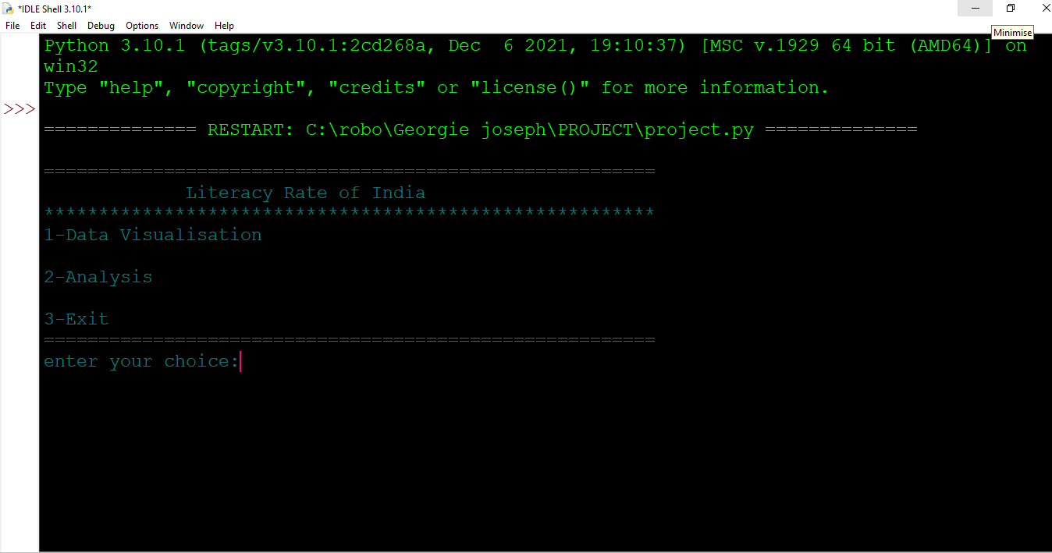

7.2 CSV FILE

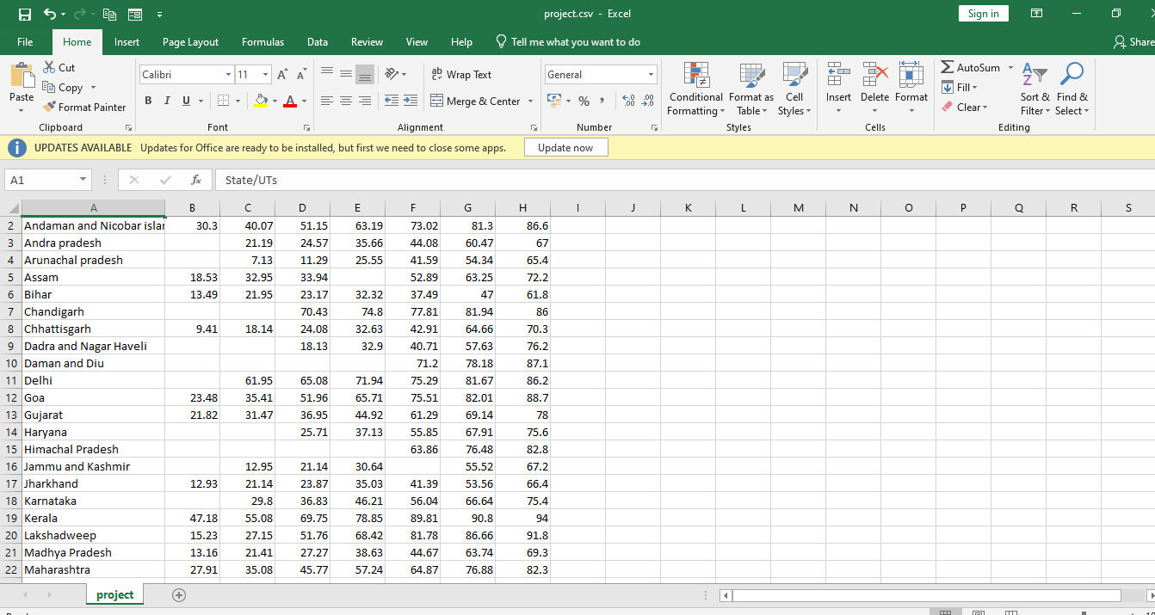

7.3 Run-Time Sample Output Windows
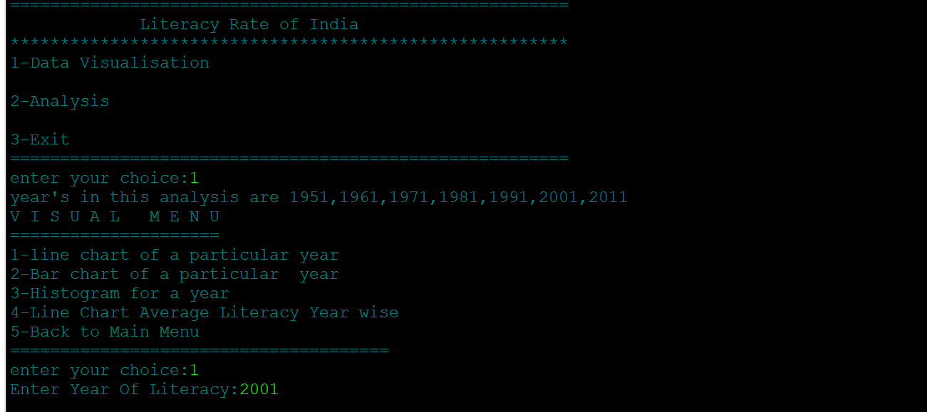

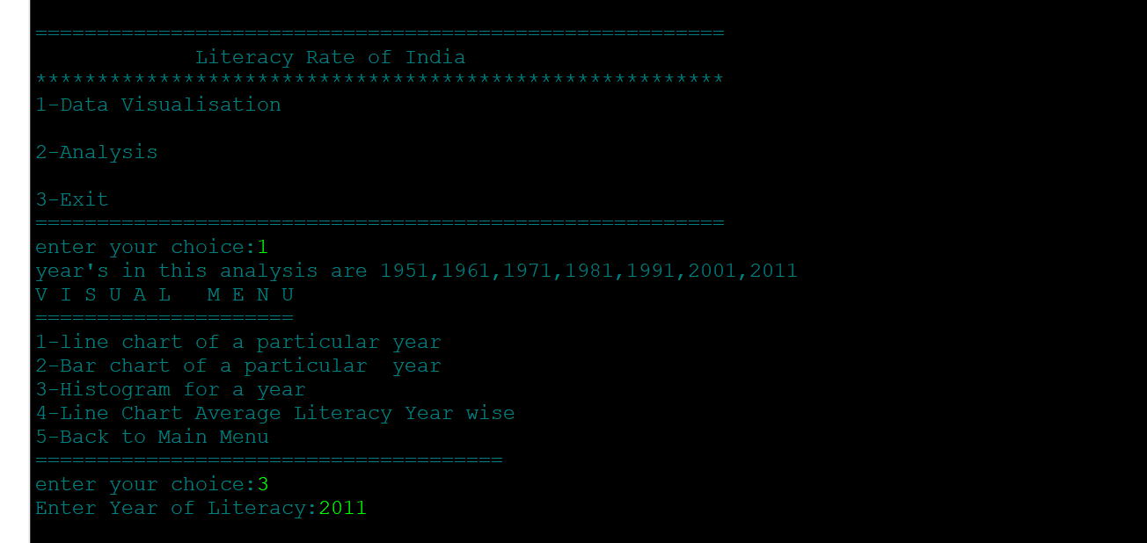

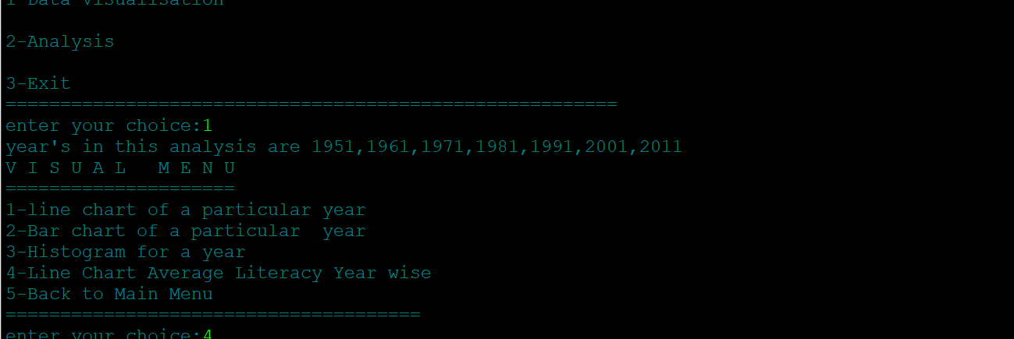
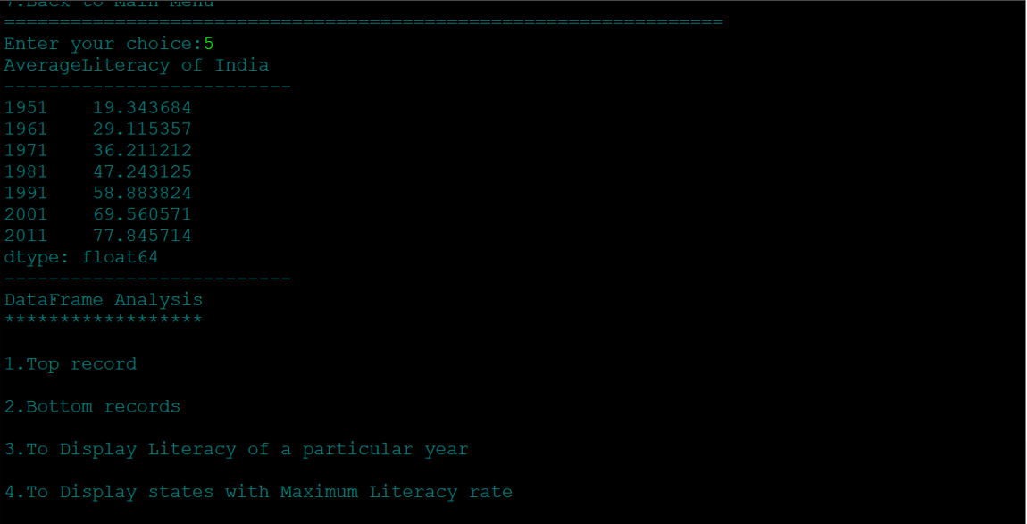

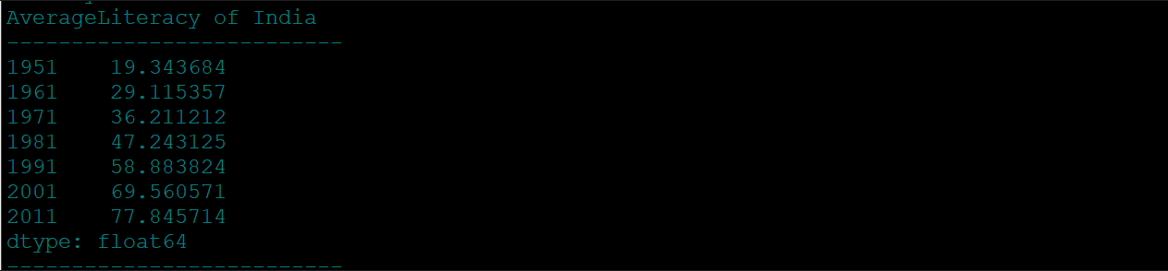

7.5 Output Chart
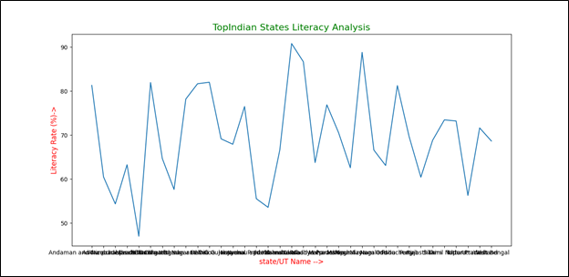
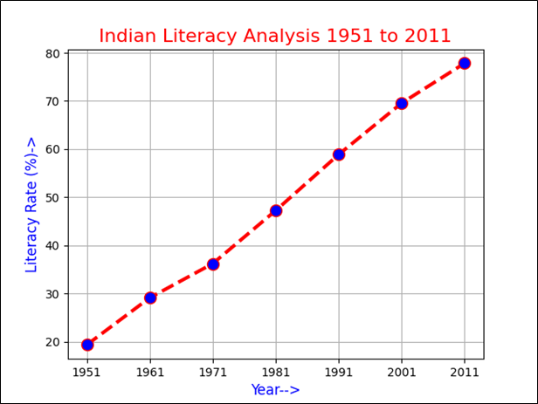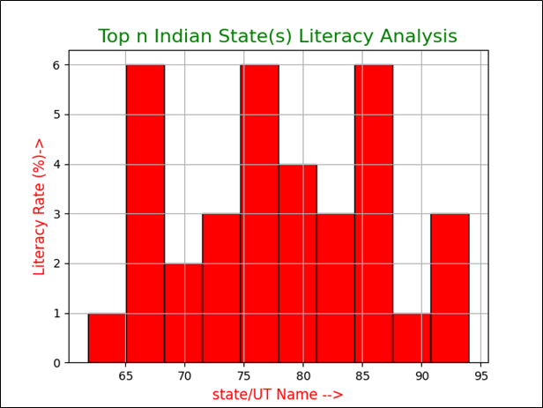
CHAPTER 8
CONCLUSION

In conclusion, our analysis of literacy rates using Python programming has provided valuable insights into the trends and disparities affecting global education. While many regions have made significant progress, notable gaps remain, particularly in underprivileged areas.
The data revealed that economic barriers, access to quality education, and cultural factors play critical roles in literacy outcomes. By utilizing Python for data analysis, we were able to efficiently process and visualize complex datasets, allowing for a clearer understanding of these challenges.
Moving forward, it is essential to implement targeted interventions, such as enhancing educational resources and promoting community involvement. By leveraging data-driven insights, we can develop effective strategies to improve literacy rates and empower individuals, ultimately contributing to stronger, more equitable communities.

CHAPTER 9
REFERENCES

- Informatics Practices - Class XII By : Sumita Arora

- Website: https://www.pythonforall.com/xii-projects

- Website : www.python.org

